Financial reasons - analysis of indebtedness, profitability and market value of a company

Instructions:

Answer the following exercises:
Problem 7-9: ROE
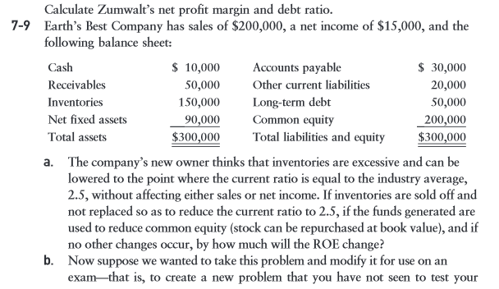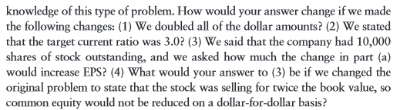
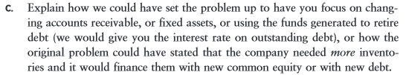

Problem 7-12: Ratio Analysis
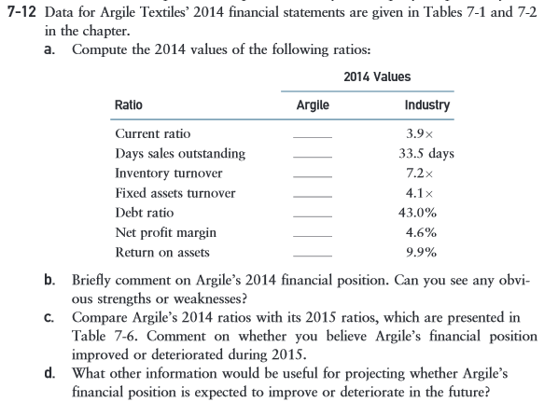

General instructions:
• Use MS Word or MS Excel to do the exercises.
• You must show the computes of each exercise to be able to evaluate all the steps that you followed to reach the final result. If you do not show the calculations, you will not accumulate the total of the points.

